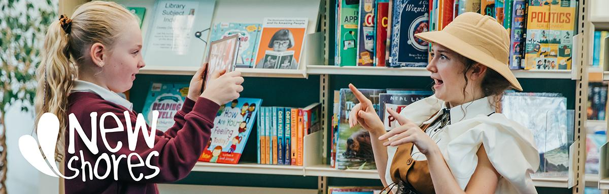

**Evaluator brief for *New Shores***

| ARCADE is seeking an experienced Evaluator, with knowledge of arts-based learning in schools, to lead and support the evaluation of *New Shores* (November 2024 – July 2026).  Deadline for submissions: Friday 1st November, 11am |
| --- |

**1 Background and context**

New Shores has been designed through a collaboration of three cultural organisations and builds on their respective experience and expertise.

[ARCADE](https://www.hello-arcade.com/)[1] is a charitable community producing company based in Scarborough and Bridlington, with a mission to:​

* Support people to work together with artists to make brilliant things happen.
* Give young people, children and their families the chance to be creative and feel confident
* Enable women and girls from working-class backgrounds to reach their full potential.

[KIT Theatre](https://www.kittheatre.org/)[2] is an award-winning not for profit theatre company. Established in 2016, KIT has worked in schools, libraries, theatres and museums across the UK sharing Adventures in Learning and Bridge Projects with communities across the UK.

* KIT’s mission is to make playful, immersive theatre for (and with) young people which develops their creativity, confidence and critical thinking while connecting them with their local creative community.
* KIT’s vision is to use immersive theatre to support the emergence of a generation of creative, confident, questioning young people; inspired through adventure.

[Scarborough Museums and Galleries](https://scarboroughmuseumsandgalleries.org.uk/) (SMG)[3] have a collection of thousands of objects (geology, art, local history) and an extensive schools workshop programme across their three venues: Woodend Gallery & Studios, Scarborough Art Gallery and the Rotunda Museum. SMG’s vision is to:

* Create warm, accessible and inclusive places where everyone feels welcomed and represented.
* Be a nationally and internationally recognised organisation with roots firmly within the community we serve.
* Develop exciting learning programmes, events and exhibitions, in our venues and externally, to engage and enthral our audiences.
* Improve our long-term sustainability by utilising our assets to develop alternative income streams.
* To inspire, engage with and invest in our team, stakeholders and partner organisations.

**2 New Shores**

*New Shores* is a locally-rooted creative partnership between ARCADE, KIT Theatre, Scarborough Museums & Galleries and four Scarborough schools, delivering a programme of arts-based learning. The schools include two mainstream primary, one Special Educational Needs and Disabilities (SEND) setting, and one Pupil Referral Unit (PRU). It is a two-year programme which aims to engage approximately 1,225 children and 12 teachers through 400 sessions. The overarching theme is ‘identity’ and ‘difference’.

Project outcomes include:

*Inspiring children*

We will inspire children and young people in Scarborough to enjoy their learning, grow confidence, critical thinking skills, improve attainment and celebrate their academic achievements.

*Developing creativity*

KIT Theatre will lead creative delivery using their award-winning *Adventures in Learning* model: immersive theatre erupting in classrooms and cultural venues to deliver learning and develop creativity. Associate artists, including Rebecca Denniff of Flash Company Arts and Touretteshero, will bring their experience of inclusive practice to the project. Alongside this, we’ll support and develop a cohort of participatory freelance artists, boosting the skills in our region and building a legacy for future work.

*Supporting teachers*

We’ll support each school to develop its own arts-based learning programme responding to their needs, built around the *Adventures in Learning* model. The project will also include bespoke teacher training and development.

*Providing resources*

We will use Scarborough Museums and Galleries’ venues, collections and resources to support immersive learning. Core themes are the environment, diversity and the celebration of differences.

*What’s an ‘Adventure in Learning’?*

Adventures begin when a character unexpectedly makes contact with pupils. Characters present a problem which only pupils can solve, leading them to abandon normal lessons and embark on a mission which just-so-happens to connect with their current curriculum topic. All adventures include literacy and oracy challenges and opportunities for pupils to explore empathy and critical thinking. The characters and quests at the heart of *New Shores* will be inspired by Scarborough Museums and Galleries.

The programme will follow a similar structure each year:

* Term 1: Teacher/Artist planning - Initial planning to understand teachers’ objectives and match their objectives with possible narratives, characters and objects in the museum collections. A full-day, bespoke CPD based on each school’s identified needs.
* Terms 2 and 3: Delivery for pupils in all schools – 1st half-term: Detailed planning and logistics agreed with all school staff. 2nd half-term: Delivery of a 6-week project including a final sharing; and a final reflection session with school staff.

**3 Purpose of the evaluation**

*To understand the outcomes and impacts of the project for children, school staff, schools, creative practitioners and partner organisations, to develop, improve and inform practice.*

We hope that the evaluation will provide a range of findings and recommendations that will support continuous improvement of our programme over the two years and will contribute to shared learning amongst all stakeholders to enable them to learn, grow and improve their ways of working over the duration of the programme and beyond.

KIT’s Adventures in Learning (AiL) is a tried and tested model in mainstream primary schools[4]. *New Shores* is taking AiL into a SEND school[5] and a PRU for the first time and we are keen to learn about the transferability of the model. These two settings will therefore have a higher priority within the external evaluation.

We would like the evaluation to address the following questions:

* How can partners best work together to co-create and deliver creative learning experiences, inspired by museum spaces and collections?
* How can schools be encouraged to make use/build relationships with local creative and cultural organisations and practitioners?
* How can partners co-create and customise AiL to provide positive outcomes for pupils in mainstream, SEND and Alternative Provision, responsive to local need?
* How can partners co-create and develop pupils’ understanding and empathy of ‘identity’ and ‘difference’ as it exists in the world around them?

**4 Evaluation Methodology**

The Evaluator will have an overview of the programme evaluation and be responsible for analysing data and presenting findings and recommendations. The evaluator will work closely with ARCADE’s Education Producer who will be responsible for gathering data, as agreed with the Evaluator.

We do not wish to prescribe the evaluation methodology, however, there are certain tasks we would like the Evaluator to undertake including:

* Co-creating an evaluation framework with the partners (initial work on the evaluation framework for the mainstream primary schools can be undertaken by the Education Producer).
* Confirm the overarching evaluation questions.
* Select and/or co-create evaluation tools, liaising with the Education Producer on the timing of data gathering.
* Gather data from: pupils and school staff at the SEND school and PRU (including at least one visit to each site, each year); and from ARCADE, KIT and SMG.
* Analyse data (Year 1 and Year 2).
* Produce an interim report in summer 2025 with recommendations to inform Year 2.
* Produce a final report in summer 2026.

*Evaluation approach and principles*

Whilst we are asking you to outline your approach across the two years, we anticipate the evaluation will:

* Combine external evaluation with internal data gathering.
* Be collaborative in approach.
* Adopt a mixed-methods approach (qualitative and quantitative; varied tools).
* Use trauma-informed practices.
* Ensure the accessibility of evaluation tools and reports, and adopt inclusive practices.
* Centre the voices of participating children and young people.

**5 What we are looking for**

*Essential capabilities:*

* Previous experience of evaluating cultural learning projects, preferably in schools and/or museums.
* Experience of working with school settings and/or knowledge of the curriculum and current priorities and challenges in schools.
* Can demonstrate a commitment to equality, diversity and inclusion and lived, learnt or practical experience of barriers to inclusion.
* Ability to design creative and engaging evaluation tools that are accessible to children and young people with a range of needs, abilities and backgrounds and with the potential to embed these in project activities.
* Ability to present ideas and findings clearly and concisely, whether in written form, verbally or visually (we are interested in accessible and alternative formats).
* Can demonstrate knowledge and/or experience of good ethical practice with regards to evaluation.
* Current Enhanced DBS (or willing to undergo one).

*Desirable capabilities*

* Previous experience of working in settings that adopt a trauma-informed approach. (Training on trauma-informed practice will be delivered to the team during the programme).

**6 Fee**

The budget for the evaluation is £5,400, inclusive of VAT and expenses.

**7 How to apply**

Please include in your submission (maximum of two pages of A4 in 12-point font plus a brief CV):

* An outline proposal setting out how you would carry out this work.
* Details of your experience and skills and their relevance to this role (you can include a brief CV as an appendix, if desired).
* An all-inclusive budget showing how you would allocate time to the varied tasks.

Deadline for submissions: **Friday 1st November, 11am**

Interviews offered in person or online on: **Thursday 21st November**

Candidates will be given one week’s notice of interview.

Candidate Appointment: **Monday 25th November**

Please send submissions to [info@hello-arcade.com](mailto:info@hello-arcade.com)

If you have any queries please email Christine Rostron, Education Producer, ARCADE: [christine@hello-arcade.com](mailto:christine@hello-arcade.com)

## 8 Access

We welcome applications from people of all backgrounds and walks of life, and we aim to be an inclusive and supportive team to work with. We especially welcome applications from those with lived experience of barriers to inclusion, as well as those with learnt or practical experience.

Please let us know if you require any support to apply, for instance:

● If you prefer this document in an alternative format please email emily@hello-arcade.com

● If you prefer to apply for the role in a different format (to that which is described above) please let us know by emailing emily@hello-arcade.com to notify us of what works for you and we will do our best to accommodate this

If you are selected for an interview, we will ask you about any access requirements you may have and we will do our best to support these.

*New Shores* is funded by Paul Hamlyn Foundation and through public funding from the National Lottery by Arts Council England.

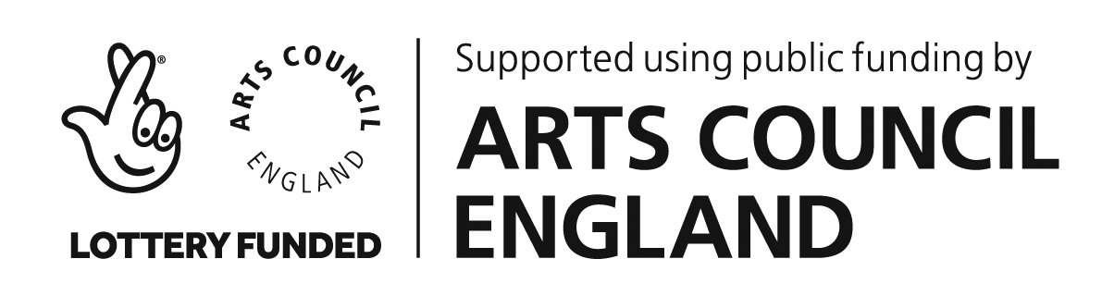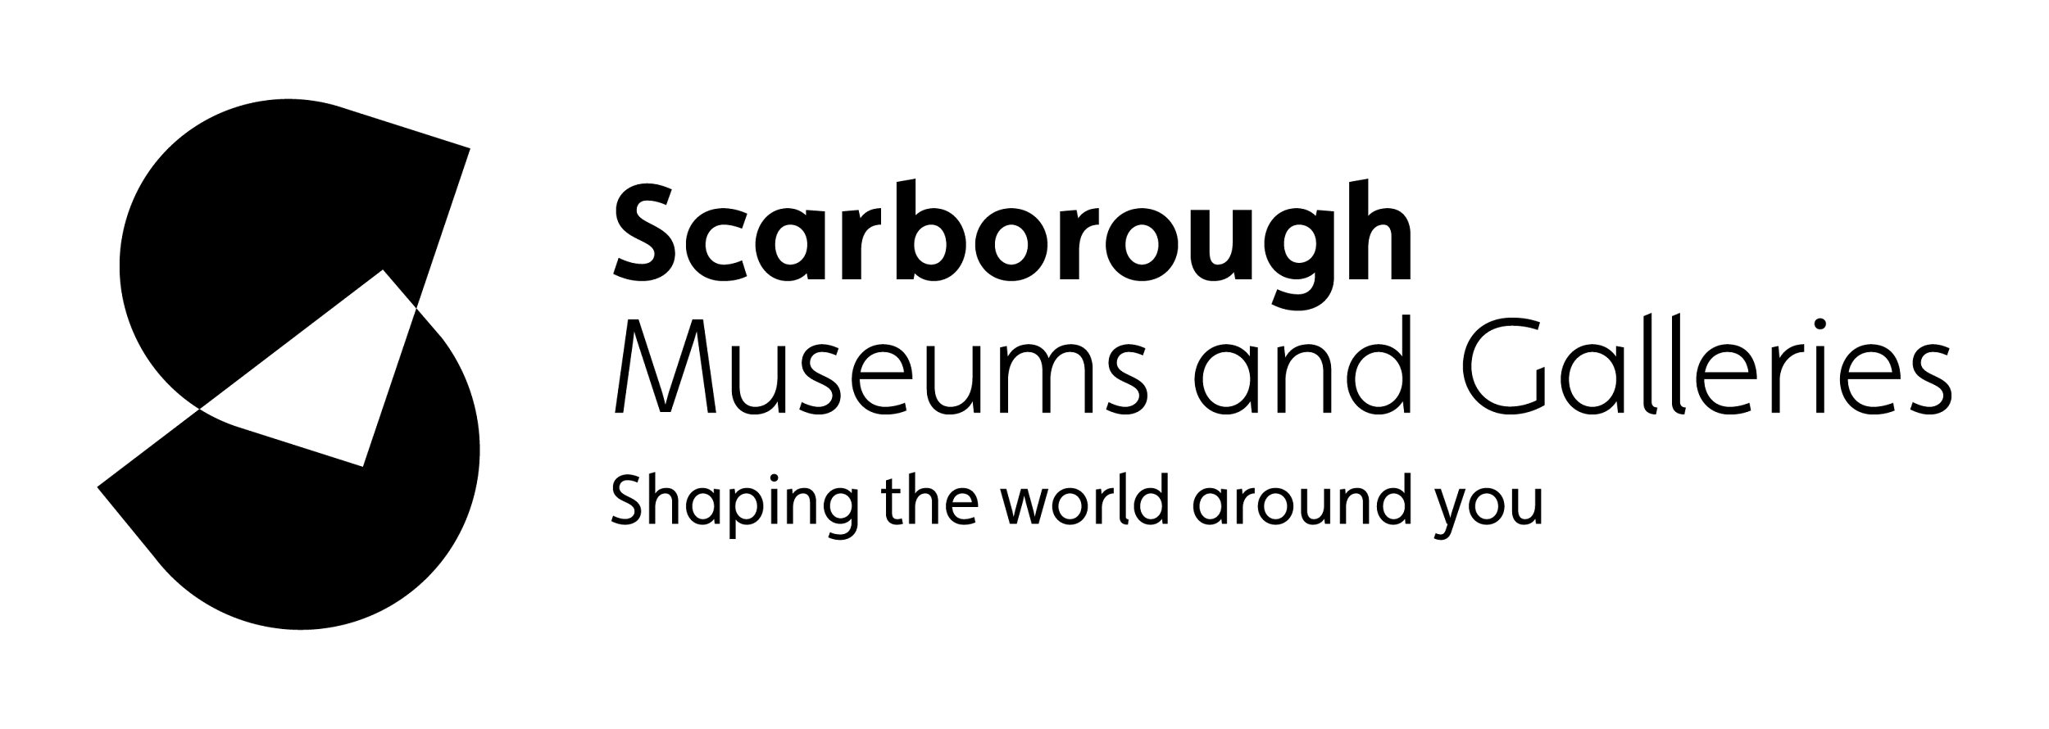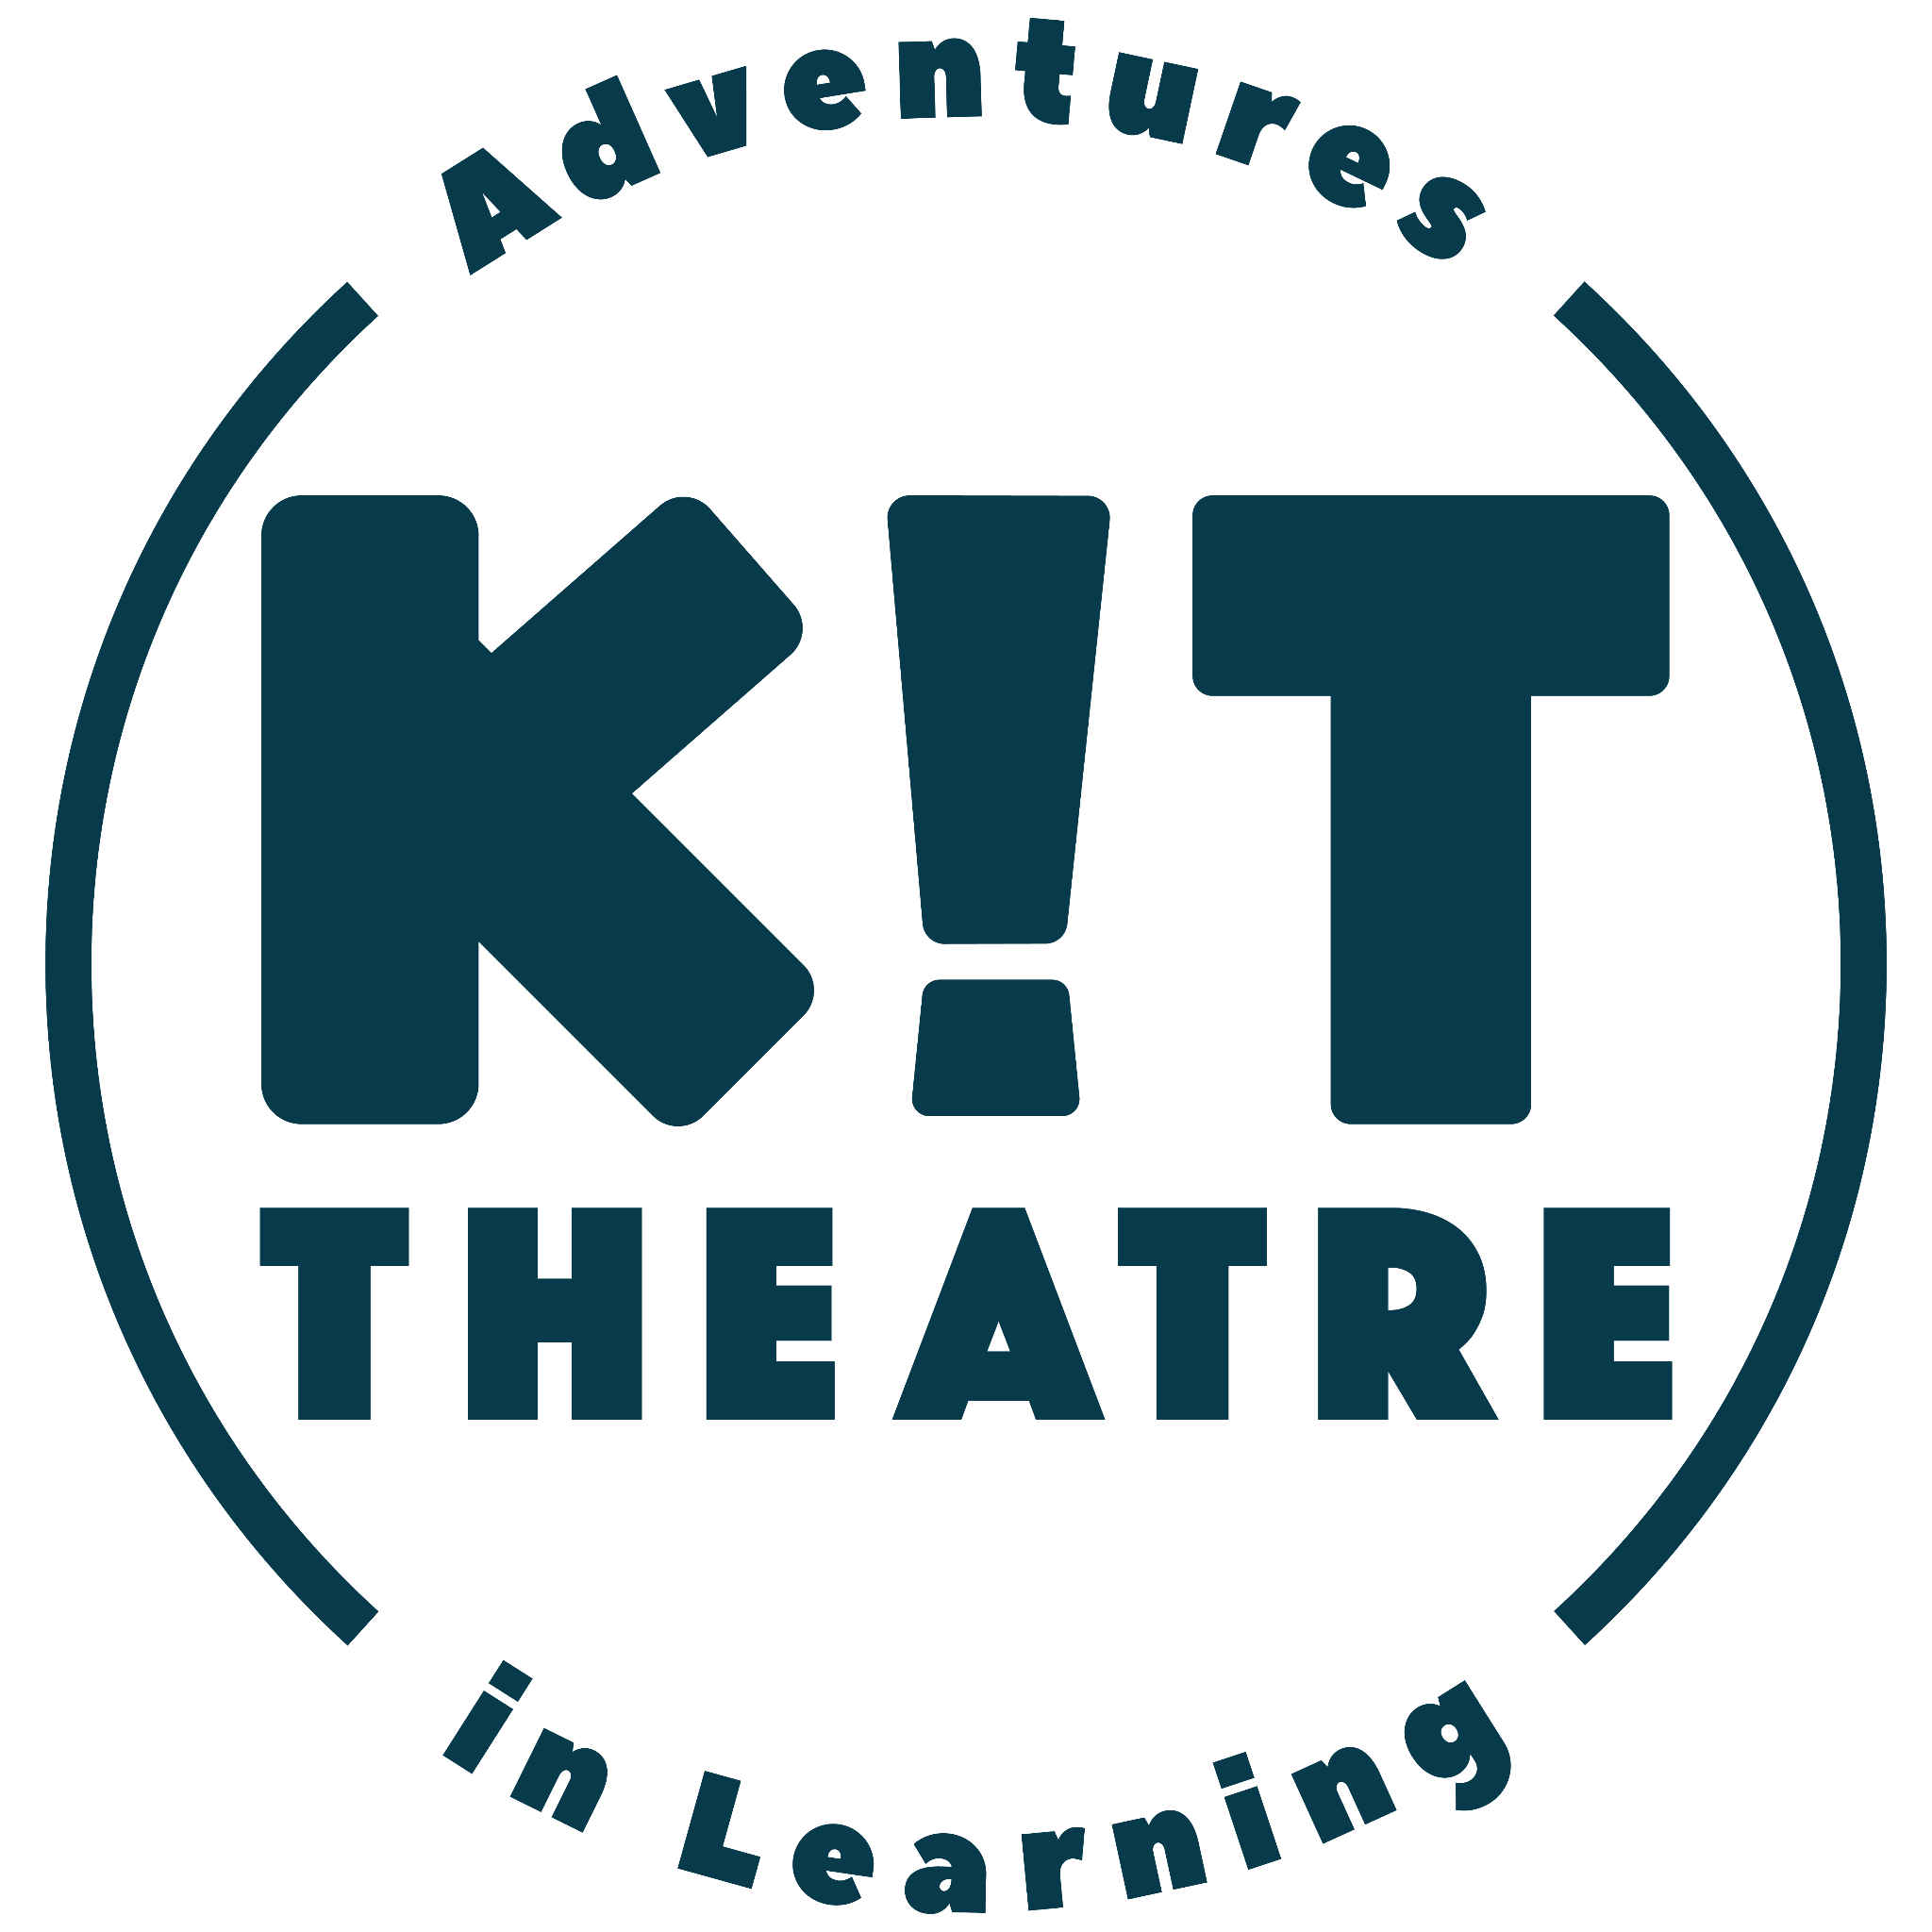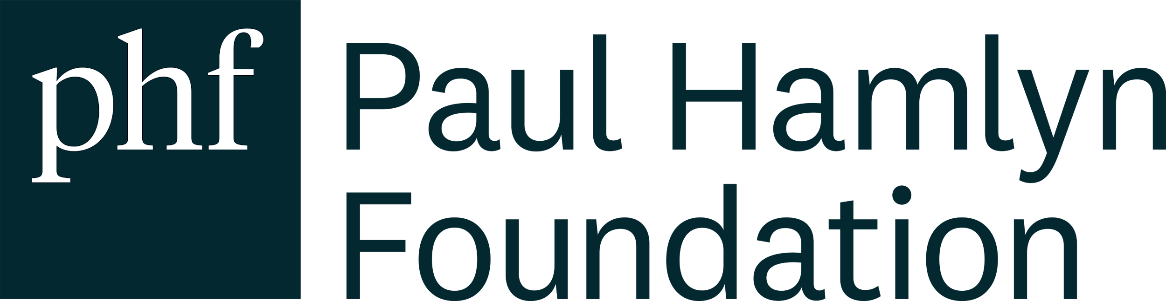

1. https://www.hello-arcade.com/
2. https://www.kittheatre.org/
3. https://scarboroughmuseumsandgalleries.org.uk/
4. https://www.kittheatre.org/kit-research
5. A specialist school for cognition and learning where pupils have a wide range of learning needs including severe or profound learning difficulties or disabilities. 