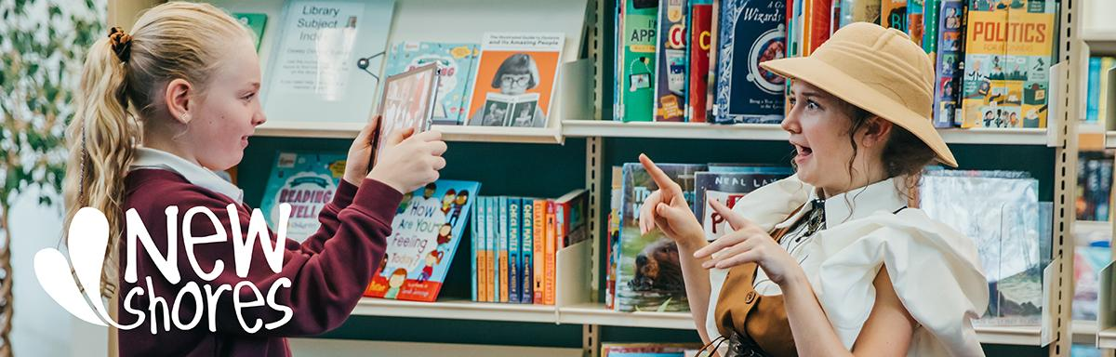**Freelance Performer - New Shores**

ARCADE and KIT Theatre are keen to hear from freelance performers/workshop facilitators to audition for a paid performer role as part of ‘New Shores’, a two year arts-based learning project in schools.

The first phase of delivery will be in February/March 2025.

Deadline to apply: **Friday 8th November, 11am**

**About Us:**

ARCADE is a producing company who make incredible arts experiences happen with communities. [You can see more on ARCADE’s work here](https://www.hello-arcade.com/).

[KIT Theatre](https://www.kittheatre.org/) creates immersive theatre for, by and with young people. They create interactive stories which erupt in schools, theatres and museums, combining theatre and game mechanics. [A short film about KIT's work can be found here.](https://www.youtube.com/watch?v=xm1oROvhdH8&feature=youtu.be)

**About ‘New Shores’:**

‘New Shores’ is a locally-rooted creative partnership between ARCADE, KIT Theatre, Scarborough Museums & Galleries and four Scarborough schools, delivering a programme of arts-based learning. The schools include two mainstream primary, one Special Educational Needs and Disabilities (SEND) setting, and one Pupil Referral Unit (PRU). It is a two-year programme which aims to engage approximately 1,225 children and 12 teachers through 400 sessions. The overarching theme is ‘identity’ and ‘difference’. [You can find out more about ‘New Shores’ here](https://www.hello-arcade.com/projects/new-shores).

KIT Theatre will lead creative delivery using their award-winning [Adventures in Learning](https://www.kittheatre.org/adventures-in-learning) model and Scarborough Museums and Galleries’ venues, collections and resources will be used to support immersive learning.

**About performer role:**

We are looking for a performer to deliver a new ‘Adventure in Learning’. The performer will work in a partner school and at Scarborough Museums and Galleries.

The performer will make in-character appearances in the partner school and at a museum venue as part of a curriculum-linked adventure.

As well as participating in scripted immersive theatre sections, the performer will also lead education-focussed elements as pupils complete creative and curriculum-focussed missions.

Being confident in facilitating while maintaining character is a key part of the role.

The role is still being developed but likely to be an eccentric archaeologist or undercover museum curator.

*Provisional dates in 2025*:

**Planning**

**Feb -** 2 days of preparation/rehearsals during week days, ie. Mon - Fri (dates negotiated to suit performer)

**Delivery**

**W.c. 24th Feb until w.c. 31st March.**  Up to 2 days per week for 6 weeks, within school hours.

**Fee:** The performer will be paid £200 per day for all rehearsal and performance days.

(Approximately 14 days @ £200, total £2800)

This exceeds ITC minimum rates. Travel expenses where appropriate and required.

All rehearsals and performances will take place in Scarborough. Rehearsals will be in accessible buildings and for performances all reasonable adjustments made within the restrictions of partners’ buildings.

There is hope to continue working with the same performer moving forward as we build the project collaboratively, and offer training and development opportunities where appropriate.

**Who we’d like to hear from:**

We are keen to hear from performers / workshop facilitators, including actors and actor-musicians with experience of working in schools and/or delivering drama-based workshops to primary age children.

Strong improvisation skills are essential.

Being confident in facilitating while maintaining character is also important.

We are especially interested to hear from people based in Scarborough and surrounding towns/cities/areas. We welcome people from all walks of life, backgrounds and ages (18+), especially those from the global majority.

All performers should have or be prepared to undertake an enhanced DBS check, and supply details of two referees.

**Application and audition process:**

To apply please send an email [info@hello-arcade.com](mailto:info@hello-arcade.com) expressing your interest and include:

* Your CV / spotlight page
* Headshot or photograph of yourself
* Your availability during the rehearsal/performance period (as above)
* Where you are based and how you’d get to Scarborough for the work
* A completed copy of our Equal Opportunities form available here as [PDF](https://www.hello-arcade.com/assets/arcade-equal-opportunities-form,-may-2024.pdf) or [DOCX](https://www.hello-arcade.com/assets/arcade-equal-opportunities-form,-may-2024.docx)

Deadline to apply is **Friday 8th November, 11am** and we will let you know if you have an audition by **Wednesday 13th November**.

Group audition workshops will take place on **Friday 22nd November** at Woodend Gallery & Studios.

If you have any access requirements to enable you to attend or take part in an audition please contact Christine Rostron, Education Producer, to let us know in advance [christine@hello-arcade.com](mailto:christine@hello-arcade.com)