Festival Programme and Information
Main Stage
13:00 | New York Brass Band North Yorkshire’s only contemporary New Orleans inspired Brass Band pack a powerful punch of relentless drums, rumbling tuba and wailing horns! Nothing kicks a party into gear like the sound of a smokin’ New Orleans Mardi Gras Jazz Band!
14:30 | Wonderful Wheels Parade Prizes Did you take part in the Wonderful Wheels Parade? Prizes for Originality, Artistic Flare and Enthusiasm! There is a prize of £100 for first place, and trophies for 1st, 2nd and 3rd place.
15:00 | Marnie Glum The pseudonym of York-born musician Charlotte Lynch, who was raised by the York folk and open mic scene. Inspired by the likes of Madison Cunningham, Big Thief, and Fiona Apple, Lynch and her bands’ sound is folk at heart, bolstered by meticulous lyrics woven into intricate guitar arrangements.
15:45 | York Dance Space Dance Flash Mob Drop in to the workshop (see below) to learn the steps, then when the dance track drops, bring your own special magic and bust a move.
16:00 | Zola Steelpan Feel-good steel pan music. R&B, Afrobeat, Indie, Reggae, Pop and more. Expect to hear hits from Taylor Swift, Bob Marley, Coldplay, Michael Jackson, Amy Winehouse, Arctic Monkeys, & Luther Vandross to name a few!
17:15 | Ghetto Fabulous - The Family Catwalk Extravaganza A fabulous celebration of self-expression for the whole family. Four dancers go head-to-head in a dance, fashion and lip sync competition where the audience decides the winner. The Family Catwalk Extravaganza includes a fierce, fun and upbeat workshop where you can practice your moves. No dance experience needed!
19:00 | Hyde Family Jam A unique fusion of irreverent covers, folk instruments, and punk energy playing pop bangers: a one-of-a-kind musical journey. With an infectious energy and musical mastery that spans decades and genres, Hyde Family Jam will have you singing and dancing. This band knows how to get the party started - and keep it going.
Cabaret / Theatre Tent
13:30 & 14:45 | The Firework-Maker’s Daughter by Next Door But One Based on Philip Pullman’s award-winning novel, this intimate and fun production is inclusive and accessible for all, featuring Makaton, puppetry, and lots of audience participation! This adventure for the whole family features talking elephants, silly kings, and magical creatures.
16:00 | Be Careful What You Wish For by Tadcaster Youth Theatre This short play by Hannah Low is inspired by the traditional Chinese folktale ‘The Magic Paintbrush’. Featuring a cast of crazy characters, talking paintings, monstrous mythical creatures, and all your wishes brought to life on stage.
16:30 | Dung Beetle Dan! by Thunk-It Theatre Join Dan, the world's most reluctant dung beetle, on a hilarious and heartwarming journey in this brand-new sensory family theatre experience. Adapted from the children's book Dung Beetle Dan Hates His Job by Andy Brennan. This interactive, inclusive performance bursts with laughs, music and just the right amount of muck!
17:30 | Say Owt Showcase: Yorkshire Comedy & Performance Poetry Formed in York in 2014, the Say Owt team host gobby and glorious gigs featuring the finest poets and comedians. This hour of heartfelt and hilarious words features unique performers from across God’s Own Country: Matt Abbott, Seeta Wrightson and Khadijah Ibrahiim.
19:00 | Bubble Disco End the day with some pop-bangers and pop some bubbles! A family disco, play-area for all the family.
VR Room
13:00 - 20:00 | Monoliths by Pilot Theatre Imaginative and immersive, this XR experience is an arresting testament to the inextricable link between person and place. Monoliths interweaves radiant renderings of three northern UK environments – a moor, a city and a coast – with sweeping soundscapes and poetic monologues by Hannah Davies, Carmen Marcus and Asma Elbadawi. *** 12 mins long slots throughout the day.
Workshops
13:00 - 15:30 | York Dance Space Drop in to learn this easy routine to Abracadabra by Lady Gaga, then when you hear the track drop from the Main Stage, take up space, bring your magic and bust your moves.
13:00 - 16:00 | Circus Skills Step right up to the amazing Circus Drop-In Zone from Circus Skills York CIC and unleash your inner performer! Have a go at juggling, tightrope and so much more. No experience needed, just a sense of adventure!
13:00 - 17:00 | Build a Mini Tadcaster A hands-on, eco-friendly creative workshop where we’ll bring the town of Tadcaster to life – in miniature! Come and build model versions of your favourite iconic Tadcaster buildings, or your very own house! All recycled materials and instructions are provided.
13:00 - 20:00 | Live Street Art with RICE Fresh off the Now Then! Tadcaster Street Art project which saw three original murals installed at The Barn, Tadcaster Community Library and Tadcaster Albion Football Ground, RICE (aka Eduard Sacrest) is back! Come and have a go at stencilling, and spray can art. All materials are supplied and full instructions are given.
Food & Drink / Stalls and Vendors
Magnets Outdoor Bar will be serving throughout the day and there will be additional drinks served from the Yorkshire Double Decker Bus Bar.
There are lots of tasty food options from Tadcaster favourites; Smokin’ Buns, Fully Loaded, and Munira Caterers, as well as Coffee and Ice Cream vans.
Local community organisations including The Barn, Tadcrafters, Albion Football Ground, Tadcaster Community Library, Sustainable Tadcaster will all be there.
Festival Locations & Timing
Now Then! Summer Fields Festival is held at:
Tadcaster Community Sports Trust (Magnets Sports & Social Club)
Queen's Garden
Tadcaster, LS24 9HD.
The Wonderful Wheels Community Parade arrives at the festival site at 12:45.
There will be somewhere to park creations (must be removed by end of day).
The festival programme runs from 13:00 - 20:00. No Dogs are allowed on site (except guide dogs and assistance dogs).

Car Parking
There are a limited number (20) disabled blue badge only car parking spaces available at Heineken Staff Car Park which can be accessed via the A162 (Doncaster / London Road).  What3Words ///keeps.departure.fled  The festival site can be accessed via a pedestrian gate at the bottom of the car park.  Please note that this carpark is also used by vendors and artists, and access will be stewarded. | 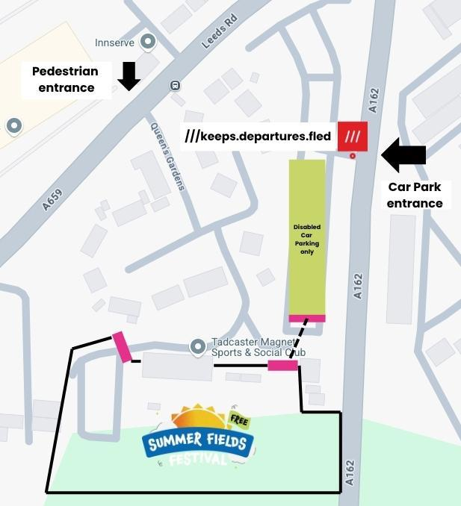
ACCESS INFORMATION
There are toilets and baby changing facilities on the festival site. Accessible toilets can be accessed inside the Magnets Clubhouse which has ramped access.
Pedestrian access from the car park is on a flat gravel path. The main festival site is on flat grass with the food court on tarmac.
There is a main stage, a large covered marquee, other small workshops, stalls, gazebos, and food trucks. There is signage on site and stewards and staff to help if needed. There are chill-out areas and quieter spaces with ear protectors and soft seating.

Enjoy the festival and have a wonderful day!

